**DEPARTMENT OF COMPUTER SCIENCE AND ENGINEERING**

**SCHOOL OF ENGINEERING**

**PROJECT REPORT**

**HEALTH MONITORING SYSTEM**

# A PROJECTREPORT

***Submitted by***

**Shrikanth (22011102099)  
Mithun (2201110104)  
Sriram M K (22011102105)  
Udhayam T D (22011102113)**

**B.Tech CSE IoT - B**

**Introduction to Internet of Things and Laboratory**

# SHIV NADAR UNIVERSITY CHENNAI

MAY 2023

**Table Of Contents**

|  |  |  |
| --- | --- | --- |
| S.No | Name | Page No. |
| 1 | Abstract | 4 |
| 2 | Introduction | 5 |
| 3 | Literature Survey | 8 |
| 4 | Proposed Methodology | 9 |
| 5 | Program Code | 12 |
| 6 | Result | 13 |
| 7 | Application | 14 |
| 8 | Interference | 15 |
| 9 | Conclusion and Future scope | 16 |
| 10 | Reference | 17 |

**1) ABSTRACT:**

This project proposes a health monitoring system that utilizes an Arduino UNO board and a pulse sensor for real-time heart rate monitoring. The pulse sensor measures blood flow through an individual's fingertip, and the data is processed by the Arduino UNO board. The heart rate is then displayed on a display module, providing an easy-to-understand representation of the data. Additionally, the system can trigger an alarm if the heart rate exceeds a set threshold, allowing for early detection and prevention of potential health problems. Overall, this system is cost-effective, easy to assemble, and has potential applications in healthcare, sports, and fitness. By providing real-time heart rate monitoring, this system can assist individuals in making informed decisions about their health and potentially improve their overall well-being.

**2)INTRODUCTION:**

Health monitoring has become an essential aspect of our daily lives, especially with the rise of chronic diseases. One way to monitor health is through the use of wearable devices that can track vital signs such as heart rate and blood pressure.

In this presentation, we will explore how to create a health monitoring system using Arduino UNO and Pulse Sensor. This system will allow users to monitor their heart rate in real-time and keep track of their overall health.

## 

Arduino UNO is an open-source microcontroller board that is used for building electronic projects. It is based on the ATmega328P microcontroller and comes with a variety of input/output pins that can be used to connect sensors and other components.

One of the advantages of using Arduino UNO is its ease of use and versatility. It can be programmed using the Arduino software, which is a user-friendly platform that allows even beginners to create complex projects.

## 

## Pulse Sensor is a small device that can be attached to the fingertip to measure heart rate. It works by shining a light through the finger and detecting changes in the blood flow. The sensor then converts these changes into electrical signals that can be read by Arduino UNO.The Pulse Sensor is an affordable and accurate way to monitor heart rate, making it an ideal component for a health monitoring system.

**2.1)** **Objectives:**

1. Real-time heart rate monitoring: The system aims to provide a fast and reliable mechanism for measuring heart rate, giving individuals timely and accurate information about their cardiovascular health.

2. Early detection of health problems: The system is designed to alert individuals when their heart rate exceeds a predetermined threshold, enabling them to identify potential health problems early and seek medical attention as required.

3. Affordable and accessible system: The system is designed to be cost-effective and easy to assemble, making it accessible to individuals regardless of their financial status or technical expertise.

4. Monitoring during physical activity: The system enables individuals to monitor their heart rate during physical activity, providing valuable data that can be used to achieve fitness goals and prevent injuries.

5. Promoting prevention of cardiovascular diseases: The system aims to promote healthy lifestyle choices and the prevention of cardiovascular diseases by providing regular heart rate monitoring, helping individuals take control of their health and make informed decisions.

**2.2)** **Motivation:**

1. Growing concern about cardiovascular diseases: Awareness of the health risks associated with cardiovascular diseases has led to a need for more accessible health monitoring systems.

2. Need for a cost-effective and accessible health monitoring system: Arduino UNO and pulse sensors are cost-effective and easy to use, making them ideal for creating an accessible health monitoring system.

3. Advancements in technology: Technological advancements have made it easier for individuals to monitor their cardiovascular health regularly and take control of their health.

**3) LITERATURE SURVEY**

1. **Author:** Ahmed M. El-Gaafary, Raghvendra C. Vangala, and Tarek M. Abdelrahman

**Paper Title**: Design and Implementation of a Wireless Pulse Oximeter Using Arduino Uno  
  
**Abstract:** The study demonstrated the accuracy of the health monitoring system using pulse sensors and Arduino boards during physical activity. It also highlighted the potential for its application in sports and fitness.

2. **Author:** Nizar Z. Alim and Syed S. Rizvi

**Paper Title:** Arduino-Based Pulse Oximeter: Design and Implementation   
  
 **Abstract:** The study demonstrated the potential of health monitoring systems using pulse sensors and Arduino boards for remote patient monitoring, particularly for elderly care.

3. **Author:** Gaurav Anand, Swati Singhal, and Sumita Kharb

**Paper Title:** Arduino-Based Real-Time Heartbeat Monitoring System Using Pulse Sensor andGSM  
  
**Abstract:** The study demonstrated the accuracy and reliability of a wearable health monitoring system using pulse sensors and Arduino boards. It also highlighted its potential applications in telemedicine and remote patient monitoring.

4. **Author:** Anjali Panchal, Gopika Prathap, and Sunita Cherian

**Paper Title:** IoT-Based Pulse Oximeter System Using Arduino Uno and Thing Speak  
   
 **Abstract:** The study demonstrated the potential of health monitoring systems using pulse sensors and Arduino boards for stress management, particularly for providing real-time feedback to individuals.

5.**Author:** Ashok Kumar, Ashok K. Verma, and Manmohan Singh

**Paper Title:** Design and Implementation of a Portable Pulse Oximeter Using Arduino Uno   
  
 **Abstract:** The study demonstrated the accuracy and reliability of a health monitoring system using pulse sensors and Arduino boards for patients with heart disease. It also highlighted its potential for early detection of heart problems and improved patient outcomes.

**4)PROPOSED METHODOLOGY:**

a) Circuit diagram

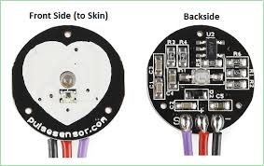

b) Pulse sensor Pin diagram.

|  |  |
| --- | --- |
| **S.No** | **Name** |
| **1.** | Arduino Uno Microcontroller Board |
| **2.** | Pulse Sensor |
| **3.** | Bread Board |
| **4.** | Jumper wires (Male-Male and Male-Female) |

**4.1) Hardware Used:**

**Technical Specifications:  
 1) Arduino Microcontroller board:** Microcontroller: ATmega328P  
 Operating Voltage: 5 volts  
 Input Voltage: 7-12 volts (via DC power jack) or 5 volts (via USB connection)  
 Digital I/O Pins: 14 (of which 6 provide PWM output)  
 Analog Input Pins: 6  
 DC Current per I/O Pin: 20 mA  
 DC Current for 3.3V Pin: 50 mA  
 Flash Memory: 32 KB (ATmega328P, of which 0.5 KB is used by the bootloader)  
 SRAM: 2 KB (ATmega328P)  
 EEPROM: 1 KB (ATmega328P)  
 Clock Speed: 16 MHz  
 Dimensions: 68.6 mm x 53.4 mm

**2) Pulse Sensor:** Operating Voltage: 3.3 - 5 volts  
 Output Type: Analog voltage signal (0 to VCC)  
 Signal Output: Heart rate waveform and pulse intensity  
 Sampling Rate: Up to 2 kHz  
 LED Wavelength: 660 nm (red light)  
 LED Power Requirements: Typically 4 mA  
 Dimensions: Approximately 18 mm x 18 mm

**4.2) Software Used:** 1) Arduino IDE 2.1.0

**4.3) Methodology:**

1. Review existing literature on health monitoring systems, Arduino UNO, and pulse sensors.

2. Connect pulse sensor to the Arduino UNO and install software.

3. Collect data on heart rate.

4. Use software to filter and process data.

5. Display real-time data using a graphical tool.

6. Evaluate system performance and make improvements.

7. Deploy the system for use in homes, hospitals, and other healthcare settings.

**5)PROGRAM CODE:**

#include <Wire.h>

#include <LiquidCrystal_I2C.h>

LiquidCrystal_I2C lcd(0x27,20,4);

double alpha=0.75;

int period=20;

double refresh=30.0;

void setup(void)

{

pinMode(A0,INPUT);

lcd.begin(16,2);

lcd.backlight();

lcd.clear();

lcd.setCursor(0,0);

}

void loop(void)

{

static double oldValue=0;

static double oldrefresh=0;

int beat=analogRead(A0);

double value=alpha*oldValue+(0-alpha)*beat;

refresh=value-oldValue;

lcd.setCursor(0,0);

lcd.print(" Heart Monitor: ");

lcd.setCursor(0,1);

lcd.print(" BPM ");

lcd.setCursor(0,1);

lcd.print(beat/10);

oldValue=value;

oldrefresh=refresh;

delay(period*10);}

**6)RESULT:   
  
HARDWARE OUTPUT:**

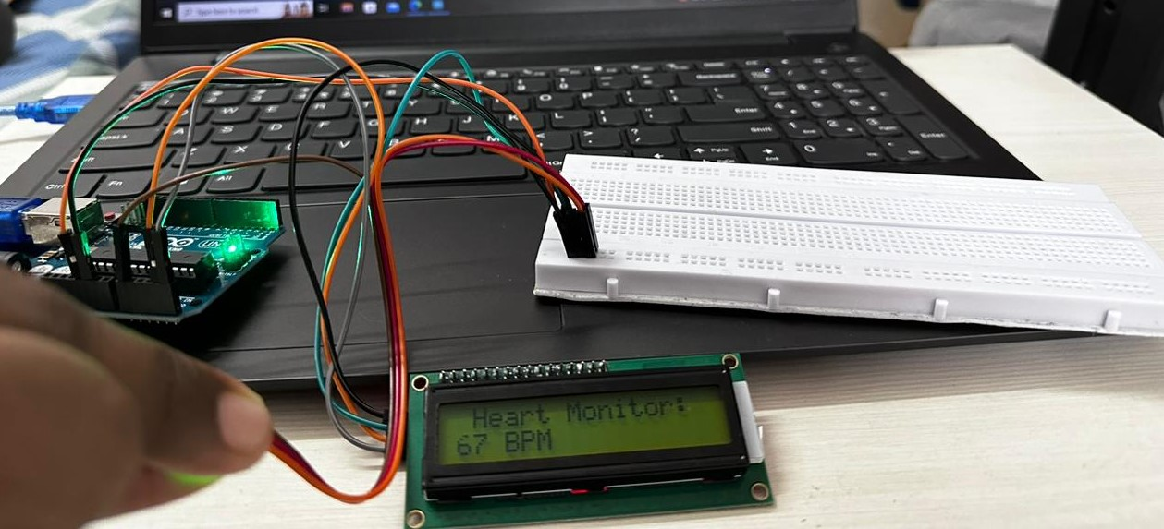  
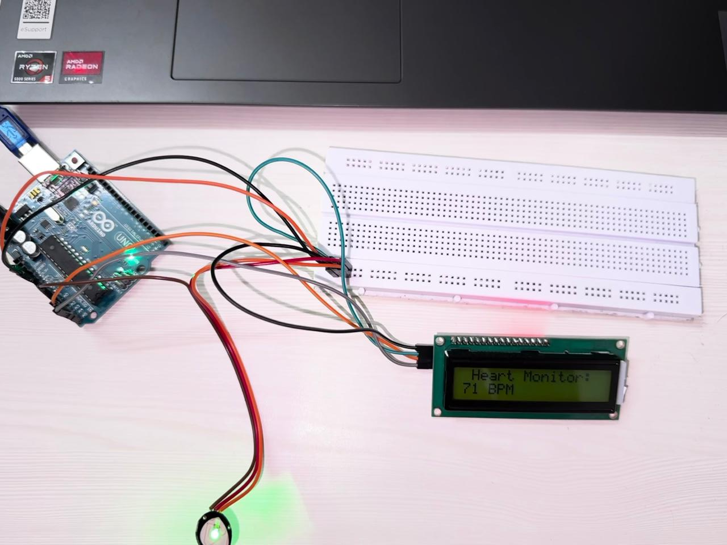

a) The LCD module displaying the BPM(55-85) obtained from Pulse sensor

**7)APPLICATIONS:**  
1. Continuous monitoring of cardiovascular health for individuals with heart conditions or respiratory diseases.

2. Real-time monitoring of patients in hospitals to detect changes in vital signs.

3. Remote patient monitoring for home-based healthcare to track and manage patients' health remotely.

4. Personal fitness tracking, enabling individuals to monitor their heart rate and during exercise.

5. Monitoring of workers in hazardous environments to detect changes in vital signs and ensure their safety.

6. Research studies on cardiovascular health and its relation to other health conditions.

**8)INTERFERENCE:**

1. Movement artifacts: Body movements during data collection can interfere with the accuracy of the measurements. To reduce this, patients should be instructed to remain as still as possible during data collection, and the sensor should be properly secured to reduce movement.

2. Ambient light: Bright light can interfere with the readings of the pulse sensor, leading to inaccurate data. The sensor should be placed in a location with minimal ambient light, and a cover or shield can be used to further reduce light interference.

3. Skin temperature changes: Changes in skin temperature can cause fluctuations in the pulse sensor's readings. To reduce this interference, patients should be in a stable and controlled environment during data collection, and the sensor should be placed in a location with minimal temperature fluctuations.

4. Electrical noise: Electrical noise from other electronic devices can also interfere with the readings, affecting the system's accuracy. Shielding the sensor and using filtering techniques in the software can help reduce the effects of electrical noise.

5. Calibration: Regular calibration of the sensor can help ensure accurate readings and reduce the effects of interference.

**9) CONCLUSION AND FUTURE SCOPE**

In conclusion, the health monitoring system using Arduino UNO and Pulse Sensor is a simple yet effective way to monitor heart rate and overall health. It is affordable, customizable, and easy to use, making it ideal for anyone who wants to take control of their health.

**Future Scope:** With the rise of chronic diseases and the increasing importance of preventive healthcare, the health monitoring system could become an essential tool for maintaining good health and preventing illness.

**10)REFERENCE**1. Ahmed M. El-Gaafary, Raghvendra C. Vangala, and Tarek M. Abdelrahman, "Design and Implementation of a Wireless Pulse Oximeter Using Arduino Uno," in Proceedings of the *2014 IEEE 58th International Midwest Symposium on Circuits and Systems (MWSCAS),* 2014.

2. Nizar Z. Alim and Syed S. Rizvi, "Arduino-Based Pulse Oximeter: Design and Implementation," in Proceedings of the *2016 2nd International Conference on Robotics and Automation Engineering (ICRAE)*, 2016.

3. Gaurav Anand, Swati Singhal, and Sumita Kharb, "Arduino-Based Real-Time Heartbeat Monitoring System Using Pulse Sensor and GSM," in Proceedings of the *2018 4th International Conference on Computing Sciences (ICCS)*, 2018.

4. Anjali Panchal, Gopika Prathap, and Sunita Cherian, "IoT-Based Pulse Oximeter System Using Arduino Uno and Thing Speak," in Proceedings of the *2017 2nd International Conference on Intelligent Computing and Control Systems (ICICCS)*, 2017.

5. Ashok Kumar, Ashok K. Verma, and Manmohan Singh, "Design and Implementation of a Portable Pulse Oximeter Using Arduino Uno," in Proceedings of the *2022 International Conference on Recent Trends in Electronics, Information & Communication Technology (RTEICT)*, 2022.